US National Academy of Sciences

An overview from the Royal Society and the

Update 2020

Evidence & Causes

ClimateChange

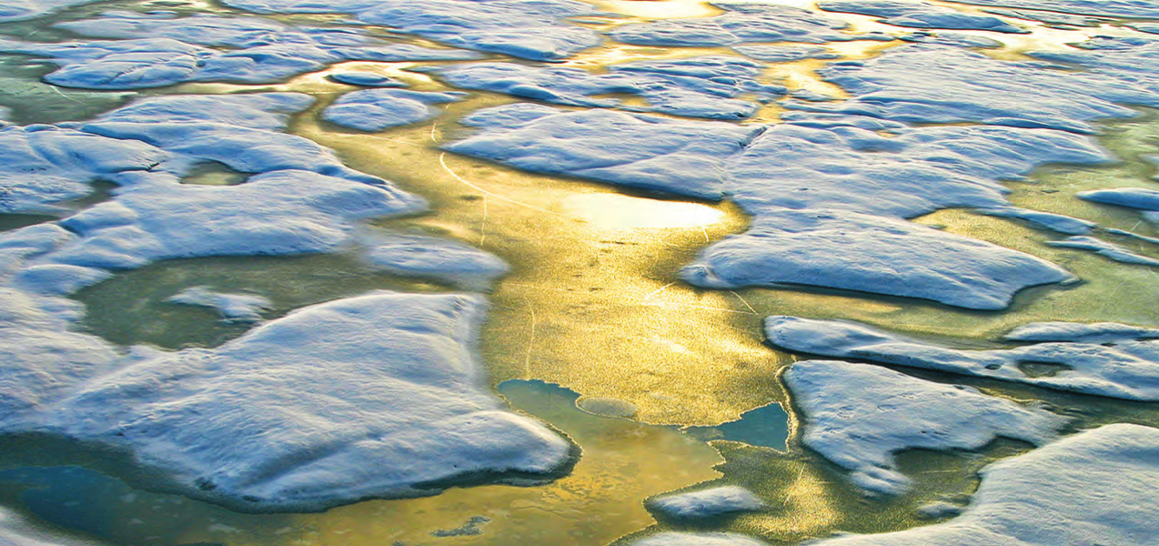

2

Climate Change

President, National Academy of Sciences

President, Royal Society

Marcia McNutt

Venki Ramakrishnan

supported by the generosity of the Cicerone Family.

current Presidents of these organizations, we are pleased to offer an update to this key reference,

these two organizations partnered to produce a high-level overview of climate change science. As

of the National Academy of Sciences, and Sir Paul Nurse, former President of the Royal Society,

We are grateful that six years ago, under the leadership of Dr. Ralph J. Cicerone, former President

authoritative answers about the current state of climate-change science.

key reference document for decision makers, policy makers, educators, and others seeking

reduce the magnitude of climate change and how to adapt to its impacts. This booklet serves as a

Scientic information is a vital component for society to make informed decisions about how to

showing increased ambition on mitigation, adaptation, and other ways to tackle climate change.

risks likely to occur within the next ten years. Yet, the international community still has far to go in

Economic Forum ranked climate change and related environmental issues as the top ve global

Calls for action are getting louder. The 2020 Global Risks Perception Survey from the World

addressed in this booklet.

These and other recent observations have been woven into the discussions of the questions

had been increasing, began to decline in 2014, reaching a record low in 2017 that has persisted.

dramatic jump to warmer temperatures between 2014 and 2015. Antarctic sea ice extent, which

For example, the period of slower warming during the 2000s and early 2010s has ended with a

be gathered around the world. Some things have become clearer and new insights have emerged.

or certain. Nor has every pertinent question yet been answered. Scientic evidence continues to

The evidence is clear. However, due to the nature of science, not every detail is ever totally settled

understanding of human-caused climate change.

updated with the most recent climate data and scientic analyses, all of which reinforce our

team of leading climate scientists. This new edition, prepared by the same author team, has been

original Climate Change: Evidence and Causes in 2014. It was written and reviewed by a UK-US

promote the use of science to benet society and to inform critical policy debates, produced the

The Royal Society and the US National Academy of Sciences, with their similar missions to

temperatures and precipitation patterns.

have cost billions in damages. Habitats are undergoing rapid shifts in response to changing

people and nature are increasingly apparent. Unprecedented ooding, heat waves, and wildres

decline in Arctic sea ice, and other climate-related changes. The impacts of climate change on

atmosphere and oceans have warmed, which has been accompanied by sea level rise, a strong

than ever, based on many lines of evidence, that humans are changing Earth’s climate. The

CLIMATE CHANGE IS ONE OF THE DEFINING ISSUES OF OUR TIME. It is now more certain

Foreword

n summary



3

Evidence & Causes 2020

available at royalsociety.org/policy/climate-change

for the benet of humanity. More information on the Society’s climate change work is

support excellence in science, and to encourage the development and use of science

purpose, reected in its founding Charters of the 1660s, is to recognise, promote, and

and medicine. It is the national academy of science in the UK. The Society’s fundamental

distinguished scientists. Its members are drawn from all areas of science, engineering,

THE ROYAL SOCIETY is a self-governing Fellowship of many of the world’s most

National Research Council are available at nationalacademies.org/climate.

causes of and potential responses to climate change. Climate change resources from the

of Sciences and the National Academy of Engineering, has issued numerous reports on the

charter in 1863. The National Research Council, the operating arm of the National Academy

States on scientic and technical issues when President Lincoln signed a Congressional

THE NATIONAL ACADEMY OF SCIENCES (NAS) was established to advise the United

[https://www.ipcc.ch/report/ar5/wg1]

Climate Change 2013: The Physical Science Basis

IPCC, 2013: Fifth Assessment Report (AR5) Working Group 1.

■

http://hahana.soest.hawaii.edu/hot/

■

http://scrippsco2.ucsd.edu

■

Context of Climate Change [https://www.nap.edu/catalog/21852]

NASEM, 2016: Attribution of Extreme Weather Events in the

■

https://www.esrl.noaa.gov/gmd/ccgg/trends/

■

https://www.ncdc.noaa.gov/

■

Science Special Reports [https://science2017.globalchange.gov]

https://ess-dive.lbl.gov/

■

USGCRP, 2017: Fourth National Climate Assessment Volume I: Climate

■

https://iridl.ldeo.columbia.edu

■

IPCC, 2018: Global Warming of 1.5°C [https://www.ipcc.ch/sr15]

■

https://climatedataguide.ucar.edu

■

Adaptation in the United States [https://nca2018.globalchange.gov]

https://data.ucar.edu/

■

National Climate Assessment Volume II: Impacts, Risks, and

discussed here are available at:

U.S. Global Change Research Program (USGCRP), 2018: Fourth

■

Much of the original data underlying the scientic ndings

[https://raeng.org.uk/greenhousegasremoval]

Royal Society, 2018: Greenhouse gas removal

of Climate Change [https://www.nap.edu/catalog/12782]

■

NRC, 2010: America’s Climate Choices: Advancing the Science

■

[https://www.nap.edu/catalog/25259]

Sequestration: A Research Agenda

climate-change-summary-science]

(NASEM), 2019: Negative Emissions Technologies and Reliable

[https://royalsociety.org/topics-policy/publications/2010/

Royal Society 2010: Climate Change: A Summary of the Science

■

National Academies of Sciences, Engineering, and Medicine

■

[https://www.ipcc.ch/srocc]

[https://www.nap.edu/catalog/12877]

Special Report on the Ocean and Cryosphere in a Changing Climate

and Impacts Over Decades to Millennia

NRC, 2011: Climate Stabilization Targets: Emissions, Concentrations,

■

Intergovernmental Panel on Climate Change (IPCC), 2019:

■

(including references to the underlying original research), see:

Surprises [https://www.nap.edu/catalog/18373]

NRC, 2013: Abrupt Impacts of Climate Change: Anticipating

■

For more detailed discussion of the topics addressed in this document

For further reading



1

Evidence & Causes 2020

Acknowledgements ............................................................................................................................ 24

Conclusion ............................................................................................................................................... 23

to the conditions of 200 years ago? ..................................................................................................... 22

20 If emissions of greenhouse gases were stopped, would the climate return

and release of methane from the Arctic a cause for concern? ............................................................ 21

19 Are disaster scenarios about tipping points like “turning off the Gulf Stream”

in our understanding of the climate system? ...................................................................................... 19

18 What are scientists doing to address key uncertainties

17 Are climate changes of a few degrees a cause for concern? ............................................................... 19

16 How condent are scientists that Earth will warm further over the coming century? ...................... 18

15 What is ocean acidication and why does it matter? ........................................................................... 17

14 How fast is sea level rising? .................................................................................................................. 16

of oods, droughts, hurricanes, and tornadoes? ................................................................................. 15

13 How does climate change affect the strength and frequency

12 Why is Arctic sea ice decreasing while Antarctic sea ice has changed little? ..................................... 14

11 If the world is warming, why are some winters and summers still very cold? .................................... 13

Climate Change Q&A (continued)

The Basics of Climate Change ............................................................................................. B1–B8

mean that climate change is no longer happening? ............................................................................. 12

10 Did the slowdown of warming during the 2000s to early 2010s

9 Does the rate of warming vary from one decade to another? ............................................................. 11

2

8 Is there a point at which adding more CO

will not cause further warming? .................................... 10

2

7 Is the current level of atmospheric CO

concentration unprecedented in Earth’s history? ................ 9

6 Climate is always changing. Why is climate change of concern now? ................................................. 9

surface up to the stratosphere—tell us about the causes of recent climate change? ........................ 8

5 What do changes in the vertical structure of atmospheric temperature—from the

4 What role has the Sun played in climate change in recent decades? ................................................... 7

human activity signicant? ...................................................................................................................... 6

2

3 CO

is already in the atmosphere naturally, so why are emissions from

2 How do scientists know that recent climate change is largely caused by human activities? ............. 5

1 Is the climate warming? ........................................................................................................................... 3

Climate Change Q&A

Summary ........................................................................................................................................................ 2

contents



2

Climate Change

human activities.

2

mainly on the total amount of CO

and other greenhouse gases emitted as a result of

continue to occur. However, long-term climate change over many decades will depend

many factors, and slowdowns and accelerations in warming lasting a decade or more will

changes in regional climate. The magnitude and timing of these changes will depend on

including substantial increases in global average surface temperature and important

greenhouse gases. Continued emissions of these gases will cause further climate change,

2

during this period is mainly a result of the increased concentrations of CO

and other

occurred in the last ve decades. Detailed analyses have shown that the warming

of heatwaves, and many other associated climate effects. Much of this warming has

strong decline in Arctic sea ice, widespread increases in the frequency and intensity

1 °C (1.8 °F). This has been accompanied by warming of the ocean, a rise in sea level, a

since 1970. Since 1900, the global average surface temperature has increased by about

2

atmospheric CO

concentrations by more than 40%, with over half the increase occurring

the burning of fossil fuels since the start of the Industrial Revolution—have increased

gases cause Earth to warm by trapping more of this heat. Human activities—especially

emitted from Earth’s surface. Increases in the atmospheric concentrations of these

2

GREENHOUSE GASES

such as carbon dioxide (CO

) absorb heat (infrared radiation)

Summary



3

Evidence & Causes 2020

Information (orange).

National Centers for Environmental

Year

and Atmospheric Administration

1850

1870

1890

1910

1930

1950

1970

1990

2010

(red), and US National Oceanic

-0.8

Goddard Institute for Space Studies

-0.6

Aeronautics and Space Administration

Centre (maroon), US National

-0.4

gov; data from UK Met Ofce Hadley

-0.2

1961−1990. Source: NOAA Climate.

1961−1990 average

0

average surface temperature of

changes are relative to the global

0.2

available data sets. The temperature

0.4

three independent analyses of the

0.6

from 1850 to 2019, derived from

NOAA (NCEI)

land and ocean measurements

0.8

NASA (GISS)

shown in this plot of combined

1.0

surface temperature has risen as

Hadley Centre (UK Met)

Annual global surface temperature (1850−2019)

Earth’s global average

Figure 1a.

monitoring systems, which gives added condence in the reality of global-scale warming of Earth’s climate.

sea level is rising [Figure 1b]. These measurements are made with a variety of land-, ocean-, and space-based

snow and ice cover are decreasing in the Northern Hemisphere, the Greenland ice sheet is shrinking, and

climate system. For example, the lower atmosphere and the upper layers of the ocean have also warmed,

A wide range of other observations provides a more comprehensive picture of warming throughout the

warmest decade in the instrumental record so far (since 1850).

very likely the warmest 30-year period in more than 800 years; the most recent decade, 2010-2019, is the

terms of the average surface temperature of Earth, these indirect estimates show that 1989 to 2019 was

sources as tree rings and ice cores help to place recent temperature changes in the context of the past. In

locations, over both the land and ocean surface. Indirect estimates of temperature change from such

places, extend back to the late 19th century. Today, temperatures are monitored at many thousands of

The clearest evidence for surface warming comes from widespread thermometer records that, in some

incontrovertible evidence of planetary-scale warming.

of temperature-sensitive species of sh, mammals, insects, etc.) together provide

ocean heat content) and indications from the natural world (such as poleward shifts

range of other observations (such as reduced Arctic sea ice extent and increased

1900, with over half of the increase occurring since the mid-1970s [Figure 1a]. A wide

1

Yes. Earth’s average surface air temperature has increased by about 1 °C (1.8 °F) since

Is the climate warming?

Q&A

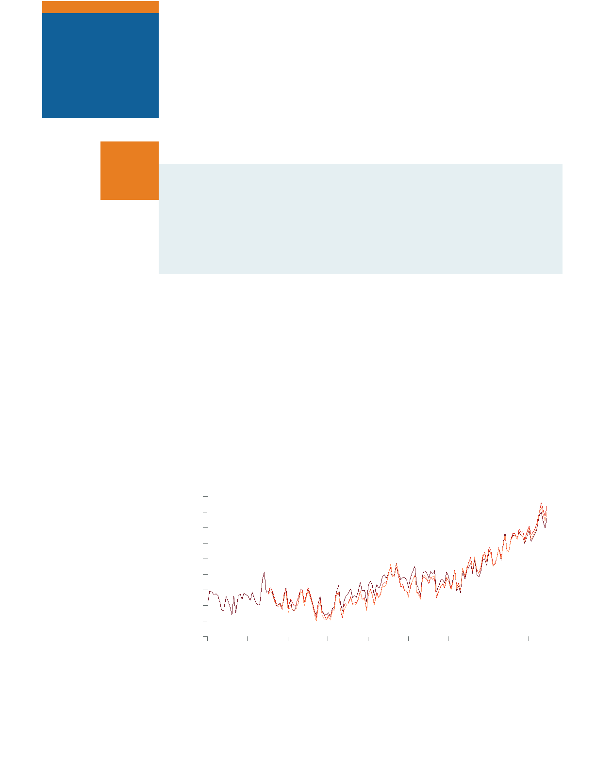

4

Climate Change

Data: Church & White 2011, UHSLC

Year

1955

1965

1975

1985

1995

2005

2015

-100

-80

-60

-40

-20

average

0

1993−2008

20

40

60

80

Global sea level (1955-2019)

Data: NOAA NODC

Year

1955

1965

1975

1985

1995

2005

2015

-10

-5

average

0

1955−2006

5

10

15

20

Upper ocean heat content (1955−2019)

Data: Rutgers Snow Lab

Year

1955

1965

1975

1985

1995

2005

2015

-6

no data

-4

-2

average

0

1967−2019

2

level. Source: NOAA Climate.gov

4

average), and the rise in global sea

(shown relative to the 1955–2006

6

700 m or 2300 feet) heat content

Northern Hemisphere June snow cover (1967−2019)

global average upper ocean (upper

Data: NSIDC

Year

Hemisphere, the increases in the

1955

1965

1975

1985

1995

2005

2015

June snow cover in the Northern

-40

in September), the decrease in

summer minimum (which occurs

minimum

extent of Arctic sea ice at its

-20

September

in the dramatic decrease in the

maximum

March

of a warming trend can be found

For example, additional evidence

0

average

1981−2010

that Earth’s climate is changing.

surface temperature records shows

20

observational evidence besides

A large amount of

Figure 1b.

Arctic sea ice extent in winter and summer (1979−2019)

n Q& A

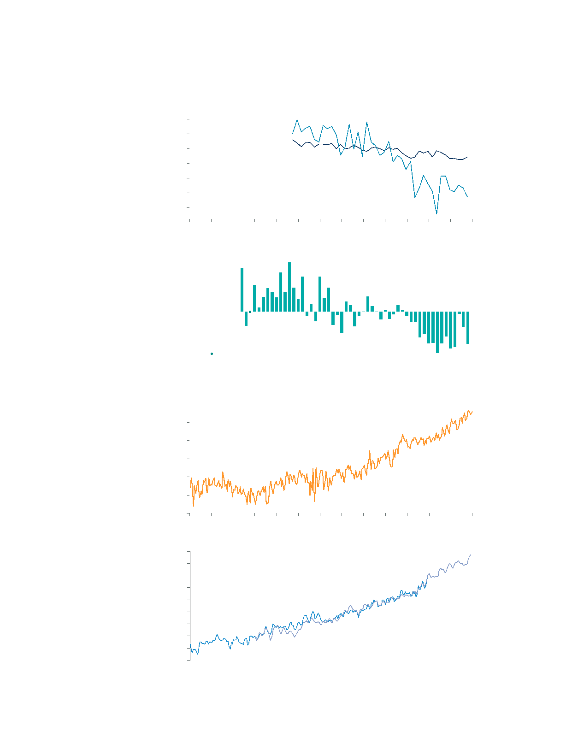

5

Evidence & Causes 2020

composition of the atmosphere are the resulting temperature changes consistent with observed changes.

slight cooling, over the 20th century and into the 21st. Only when models include human inuences on the

natural factors were inuencing the climate system. These simulations yield little surface warming, or even a

(see infobox, p. 20) have been used to simulate what would have happened to global temperatures if only

internal uctuations in the climate system (such as El Niño and La Niña). Calculations using climate models

causes include variations in the Sun’s output and in Earth’s orbit around the Sun, volcanic eruptions, and

show that natural causes alone are inadequate to explain the recent observed changes in climate. Natural

this fundamental understanding of the physics of greenhouse gases and pattern-based ngerprint studies

The expected changes in climate are based on our understanding of how greenhouse gases trap heat. Both

scientists expect to see due to human activities (see Question 5).

in atmospheric moisture, sea level rise, and increased melting of land and sea ice also match the patterns

surface warming, temperature changes through the atmosphere, increases in ocean heat content, increases

by looking instead at the geographical and seasonal patterns of climate change. The observed patterns of

easier to see by probing beyond a single number (such as the average temperature of Earth’s surface), and

Different inuences on climate have different signatures in climate records. These unique ngerprints are

energy balance.

of the observed increase in atmospheric greenhouse gases (and other human-induced changes) on Earth’s

observed global surface temperature rise since 1900 is consistent with detailed calculations of the impacts

gases (notably methane and nitrous oxide) are also increasing as a consequence of human activities. The

of carbon (isotopes, see Question 3) reveal that this increase is due to human activities. Other greenhouse

2

that atmospheric CO

increased by more than 40% from 1800 to 2019. Measurements of different forms

2

to Earth’s energy balance. Direct measurements of CO

in the atmosphere and in air trapped in ice show

2

Since the mid-1800s, scientists have known that CO

is one of the main greenhouse gases of importance

the detailed patterns of climate change caused by different human and natural inuences.

understanding of basic physics, comparing observations with models, and ngerprinting

Scientists know that recent climate change is largely caused by human activities from an

human activities?

2

climate change is largely caused by

How do scientists know that recent

Q& A n



6

Climate Change

concentrations are substantially higher than they have been in at least 800,000 years (see Question 6).

2

years. Comparison with the CO

levels measured in air extracted from ice cores indicates that the current

in the atmosphere, where some of it will remain not just for decades or centuries, but for thousands of

2

atmosphere. As a result, a substantial fraction of the CO

emitted from human activities accumulates

2

restore the balance are too slow compared to the rates at which human activities are adding CO

to the

deforestation has disturbed the balance of the carbon cycle, because the natural processes that could

2

where it normally resides for decades to centuries. The additional CO

from fossil fuel burning and

Deforestation and other land use changes have also released carbon from the biosphere (living world)

2

the rise in CO

is largely from combustion of fossil fuels (which have low

C fractions and no

C).

13

14

atmospheric oxygen concentration (observations of which have been available since 1990) show that

decreases in the fraction of other forms of carbon (the isotopes

C and

C) and a small decrease in

14

13

has taken place since 1970, about the time when global energy consumption accelerated. Measured

2

2

The CO

level in 2019 was more than 40% higher than it was in the 19th century. Most of this CO

increase

weathering of rocks.

also emitted in volcanic eruptions. This is balanced by an equivalent amount that is removed by chemical

2

exchange. A very small amount of CO

(roughly 1% of the emission rate from fossil fuel combustion) is

photosynthesis, respiration, and decomposition, and between the atmosphere and ocean through gas

2

In nature, CO

is exchanged continually between the atmosphere, plants, and animals through

2

buried fossil fuels and burning them for energy, thus releasing CO

to the atmosphere.

Human activities have signicantly disturbed the natural carbon cycle by extracting long-

human activity significant?

3

naturally, so why are emissions from

2

CO

is already in the atmosphere

n Q& A

